Receive a Free Microscope

Help to Erase Pathology’s Borders
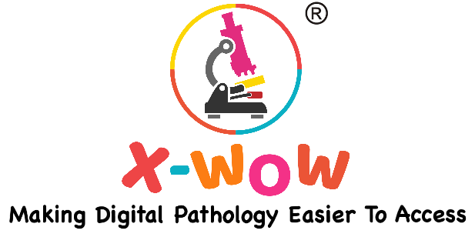

Our Goal
X-WOW is a social enterprise aiming to establish a digital diagnostic network to erase pathology’s borders which allows pathologists from all around the world to make diagnostic decisions together digitally, remotely, rapidly and confidently, through 3 easily accessible digital pathology solutions, which are:
- “X-WOW Whole Slide Imaging System”: a smart software and a tiny camera piece that turns your microscope into an intelligent whole slide scanner.

- “Digital Diagnostic Platform”: an online platform that connects pathologists in need and global talents who can help for diagnose or second opinion, at an affordable price, or even voluntarily.

- “Retired microscope/scanners Back to Shine”: we rehome retired microscopic equipment to support pathologists in need.

Currently we are donating numbers of microscopes to pathologists who has:
- urgent needs for remote diagnosis/education but can’t affordable a microscope.

- commitment to work with X-WOW and establish a pathology network without borders together.

If you believe you are eligible, we are here to help. However, we will need you to justify your reasons, to make sure you are worthy of those equipment which have been cared with love by their previous owners, and we can rely on you for future collaboration. Therefore, please make sure to answer all the questions, and please be specific, and be as details as possible, and also be creative. Certainly there are questions we have not considered and provided in this application, so it’s important to tell everything you want us to know.

1. Tell us about your background, why did you choose pathology and what are you doing now?
e.g. What is your current status? Resident? Fellow? Pathologist in practice? How many years have you been in practice, country of practice. Practice settings, Community hospital, Teaching hospital, private practice or others.

2. Tell us about your lab in need, history and current, and what/how many slides do you make. Is there a website?

3. Tell us about your patients, what are the most common diseases, and what’s their needs.

4. How much do you know about digital pathology and what experience do you have to use digital pathology for routine clinical diagnosis.

5. If we are providing you a microscope, what difference/impact will you make with it? What are the achievement that you can bring to life but not the top tier labs in the world.
Please visit the following pages to see what our past successor have achieved. Please be creative and unique!
https://www.x-wow.com/xwowkidsclub
https://www.x-wow.com/futurevetpathologists
https://www.x-wow.com/thankyouolaleke

6. Please also note that once the equipment is provided, we will not be guaranteed to provide further support such as equipment maintenance and repair. Please explain your solutions to the above potential challenges.

7. Please share photos of the current situation of you/your lab (the more the better). If you are successful, we would request you to share more photos and feedback on the monthly basis to keep us updated. We would also like to use them to write articles, media, publish on websites and social network. Please let us know if you are happy with this.

8. What do you see the potential of digital pathology and artificial intelligent for remote diagnosis? For your organisation, and the rest.

9. What’s your needs for remote consultation? How is it being done at the moment when 2nd opinion or primary reporting is required from pathologists from a different hospital and how often do you need this, free/paid? If possible, please share the cost and from where do you receive this service from?

10. If there is any, please provide leads of:
- Other pathologists in need who are also eligible for a microscope.
- Potential funding source for further assistants (local charity organisation, philanthropists).
- Media support that could help promoting our work.
- Pathologists who are willing to contribute (2nd opinion/primary diagnosis/education)

11 Is there anything else we need to know? For example, potential issue when the shipment entering the custom.

12. We have so far received quite a number of interests from pathologists in the EU/US/UK/Brazil who are willing to offer remote support, please explain how they could potentially help you.

13. What is the ONE OTHER equipment that are urgently needed for the pathology lab at your lab?

14. How reliable is the internet connection at the hospital and what’s the speed? Please visit https://www.speedtest.net/ and provide a screenshot of the test result. How good is your computer and how many are there?

15.How do you currently manage the pathology workflow? Is there an information management system currently being used at the moment?

16. how do you make sure the equipment is securely stored?

17. What’s the total responsible patient population in the town, %? The situation of the surrounding hospitals, local hospitals (how many, has or does not has this pathology service). Do patients go to other hospitals? What are the potential to expand the service of your lab to serve more patient and more hospital if you are given the scanner and potentially remote assistant from other countries?

Please sign the application, and return it to admin@x-wow.com
Once your application is received it will be reviewed by a panel of experts in digital pathology. Please note that we are currently receiving high volume of applications, but we will contact you again by email to let you know whether or not you have been selected to receive a scanner.
We look forward to hearing from you!
Sign:___________
Date:___________

